**DownDetect: An AI-Powered Early Detection and Support System for Down Syndrome via Ultrasound Imaging**

Mark Emad, Sama Mahmoud, Farah Waleed, Omar Ahmed, Mahmoud Yakout, Esmaiel Ahmed, Micheal Zakaria, and Amira ElGouhary

School of Computer Science, Canadian International College (CIC), Cairo, Egypt

**Abstract**  
 Down syndrome, also known as trisomy 21, is a genetic condition characterized by developmental delays, intellectual disabilities, and recognizable physical features. Early detection during pregnancy is crucial, as it allows parents to make informed decisions and prepare for necessary medical care. The DownDetect system offers a non-invasive and user-friendly solution to support early screening by analyzing ultrasound images. The app guides users through a simple and intuitive process: expectant parents begin by uploading ultrasound images through a clean, accessible interface. The system then performs an initial screening and presents the results in a clear and understandable format. In addition to screening, the app provides educational resources, video content, and emotional support materials to assist parents throughout their journey. This structured flow—from image upload to results and support—enhances early awareness and encourages timely consultation with healthcare professionals. The system demonstrated strong performance, achieving 93% accuracy in detecting Down syndrome from ultrasound images, indicating its potential value in prenatal care

**Keywords**: Down syndrome, Machine Learning, Image Processing, deep learning, Convolution Neural Network(CNN) , Artificial intelligence(AI) , receiver operating characteristic(ROC),).Area under the curve(AUC)

# Introduction

Down syndrome is the most common chromosomal abnormality, affecting approximately 1 in 1,000 live births globally and about 1 in 700 in the United States. As of 2015, around 5.4 million people were living with Down syndrome worldwide, with 27,000 deaths that year—down from 43,000 in 1990. The syndrome is named after British physician John Langdon Down. Raising a child with Down Syndrome can be overwhelming for families. Traditionally, diagnosis relied solely on physical examinations, medical history evaluations, and physician insights, prior to the development of intelligent imaging systems [1]. After diagnosis, many parents are unsure of the next steps. While healthcare systems may offer support, there is often a lack of integrated platforms that combine medical expertise with practical tools for early intervention and long-term planning, leaving families without adequate guidance [2].The Early Detection and Support System for Down Syndrome addresses these challenges by integrating advanced sonar technology with artificial intelligence. This research utilizes detailed ultrasound image analysis and CNN-based classification for early diagnosis [3]. Beyond detection, our system offers a comprehensive ecosystem tailored to family needs. The system uses a dataset of real ultrasound images, classified as Standard or Non-standard. It employs a Convolutional Neural Network (CNN), specifically EfficientNetB0 pre-trained on ImageNet, achieving 93% accuracy for reliable early detection. Deep learning models like this have demonstrated significantly greater accuracy in medical imaging than traditional methods [4].Similar approaches have succeeded across various medical domains. CNN-autoencoder models have outperformed conventional algorithms in tumor detection [5], while ensemble pre-trained models reached over 96% accuracy in Alzheimer’s diagnosis [6]. Other hybrid systems combining CNNs with support vector machines (SVMs) and deep neural networks (DNNs) achieved 100% classification accuracy in MRI brain scans [7], especially when enhanced with patient metadata like age and gender [8].Deep learning architectures clearly outperform traditional methods in image classification tasks [9], though challenges remain in terms of computational cost and scalability. To mitigate this, researchers are exploring quantum computing. Quantum neural networks can handle more complex models with greater efficiency [10], and recent hybrid quantum-deep learning architectures show promising improvements in training and inference [11], [12]. The system is designed to empower parents and caregivers by offering educational content, therapeutic resources, behavioral tools, and access to local services like therapy centers and recreational activities. By centralizing these features in our system, it supports families in providing optimal care for their children. The Early Detection and Support System for Down Syndrome merges advanced technologies with a strong focus on family-centered support, bridging the gap between clinical diagnosis and home-based developmental care.

The primary contribution of the paper can be outlined in the following points:

(a) The system uses AI to accurately detect Down syndrome early from ultrasound

images, helping parents begin care sooner.  
(b) It offers families a complete support platform with educational resources, therapy

tools, and access to local services.  
(c) Our system connects clinical diagnosis with daily care, making it easier for families to manage and support their child’s development.

The remainder of this paper is structured as follows: Sect. 2 discuss the dataset and the distribution of it before and after augmentation Sect. 3 discusses the overall proposed Down Syndrome detection system. The description of the adopted dataset is discussed in Sect. 4. The experimental results and discussion are presented in Sect. 5. Finally, a summary of the main findings with potential directions for future research is presented.

# Dataset Description

The dataset used in the DownDetect system consists of real ultrasound images categorized into two main classes: Standard and Non-standard. The original dataset was divided into three main directories: **train, validation,** and **test,** with each containing subfolders for the respective classes. Additional augmentation was performed on the Non-standard class to address data imbalance and increase the robustness of the model. The augmented dataset was preprocessed to ensure all images were resized to a uniform shape of 224x224 pixels. The preprocessing pipeline involved resizing, normalization, and label encoding. The original dataset consisted of 1,061 images labeled as Standard and 311 images labeled as Non-Standard, indicating a significant class imbalance. To address this issue and enhance the model’s ability to generalize, data augmentation techniques were applied to the Non-Standard class. As a result, the dataset distribution was balanced to 1,061 Standard images and 1,244 Non-Standard images.[13]

The following tools and libraries were used during the development: Google Colab for cloud-based training and experimentation, TensorFlow / Keras for building and training the deep learning model, OpenCV for image processing and resizing, Albumentations for data augmentation techniques like rotation, flipping, brightness, and noise injection, Matplotlib & Seaborn for visualization and performance evaluation, NumPy & Pandas for data handling and transformations, and scikit-learn for metrics and evaluation tools.

Figure 1 shows the class distribution on the original Dataset

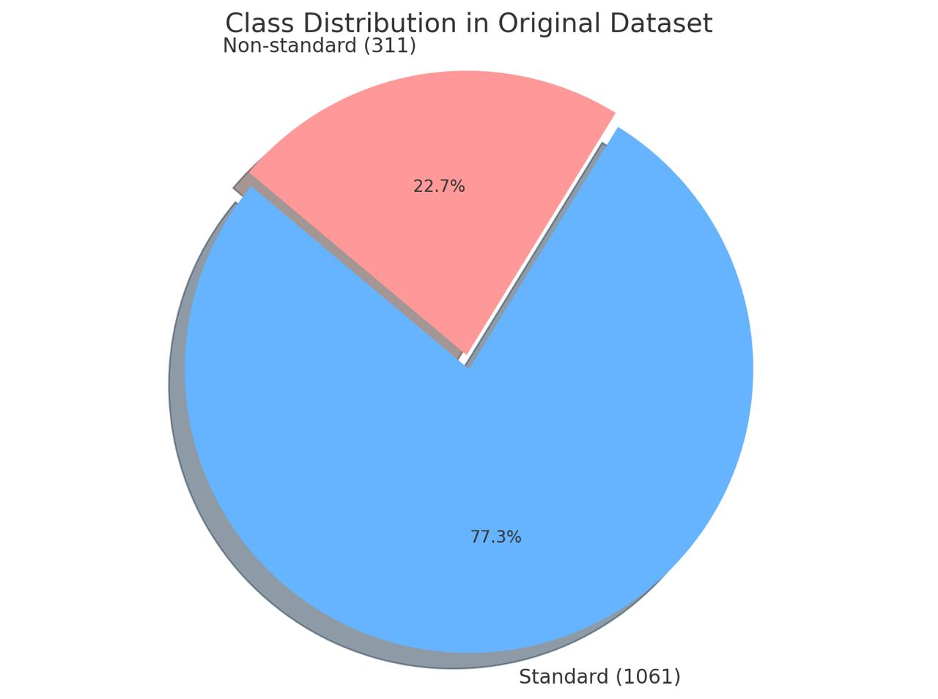

# Proposed System: DownDetect

The proposed DownDetect mobile application is structured into two primary phases: the frontend and the backend. The frontend phase focuses on designing the System's user interface and visual scenes, utilizing Flutter as the core development platform due to its robust support for cross-platform deployment. This phase is dedicated to crafting an engaging, intuitive, and accessible interface, ensuring a smooth and immersive experience for users.

In contrast, the backend phase manages the core operations behind the scenes, including data processing, storage, and the implementation of business logic. It acts as the system's foundation, enabling reliable performance, secure data handling, and efficient functionality.

This paper leverages a carefully curated dataset to address critical challenges faced by families of children diagnosed with Down Syndrome. Early detection and timely intervention are crucial for enhancing developmental outcomes. However, many families—particularly those in underserved or remote areas—lack access to affordable diagnostic tools and educational support. By integrating advanced AI technologies and expert-curated resources, this system aims to close that gap, empowering families to offer better care for their children. Moreover, it's emphasis on inclusivity, accessibility, and community engagement underscores a strong commitment to equitable opportunities for all families, regardless of their geographical or socioeconomic circumstances.

### 3.1 Front-End Phase

The front-end phase of **DownDetect** focuses on creating a user-friendly, interactive experience for individuals seeking to detect indicators of Down Syndrome through image analysis. Built using the Flutter framework, our system offers a seamless, cross-platform interface compatible with multiple systems. Upon launching the it, users are greeted with a clean and intuitive home screen that enables them to upload an image from their gallery. This simple and accessible process ensures that even non-technical users can navigate the system with ease. Once an image is selected, the front end initiates a request to the integrated analysis model. During this stage, the user interface displays a loading indicator to provide real-time feedback and maintain transparency, thereby building user trust. After the analysis is completed, the results are presented in a clear and concise manner, accompanied by a confidence score. This immediate feedback helps users understand the likelihood of Down Syndrome traits being present in the submitted image. The interface includes additional options such as reselecting the image or returning to the home screen, allowing users to restart the process without confusion. The design prioritizes simplicity and clarity over complexity, ensuring a smooth and accessible experience. Internally, this phase utilizes Flutter's widget-based architecture to manage screen updates and transitions between image input, result processing, and outcome display. The system also integrates educational videos from platforms like YouTube to help parents gain a better understanding of Down Syndrome. Furthermore, it includes an appointment booking feature to directly connect users with medical professionals, as well as a community widget that provides a dedicated communication space for parents to ask questions, share experiences, and support one another. It is important to note that the front-end experience is tightly integrated with the underlying model and processing logic, enabling real-time interaction between user actions and system responses. The front end not only facilitates this communication but also presents the results in a manner that is accessible, understandable, and responsive—an essential consideration given the sensitive medical context. And here are some samples of the the user interface (UI), the first screen is the uploading ultrasound image and the second screen the the detection screen which will appear to the user after uploading the image and the third screen is the therapist screen which will help the user for finding the best therapist.

Figure 2 shows samples from the system.

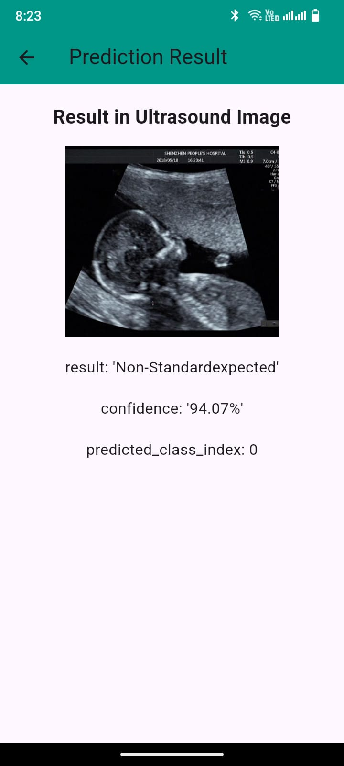

**(c)**

**(b)**

**(a)**

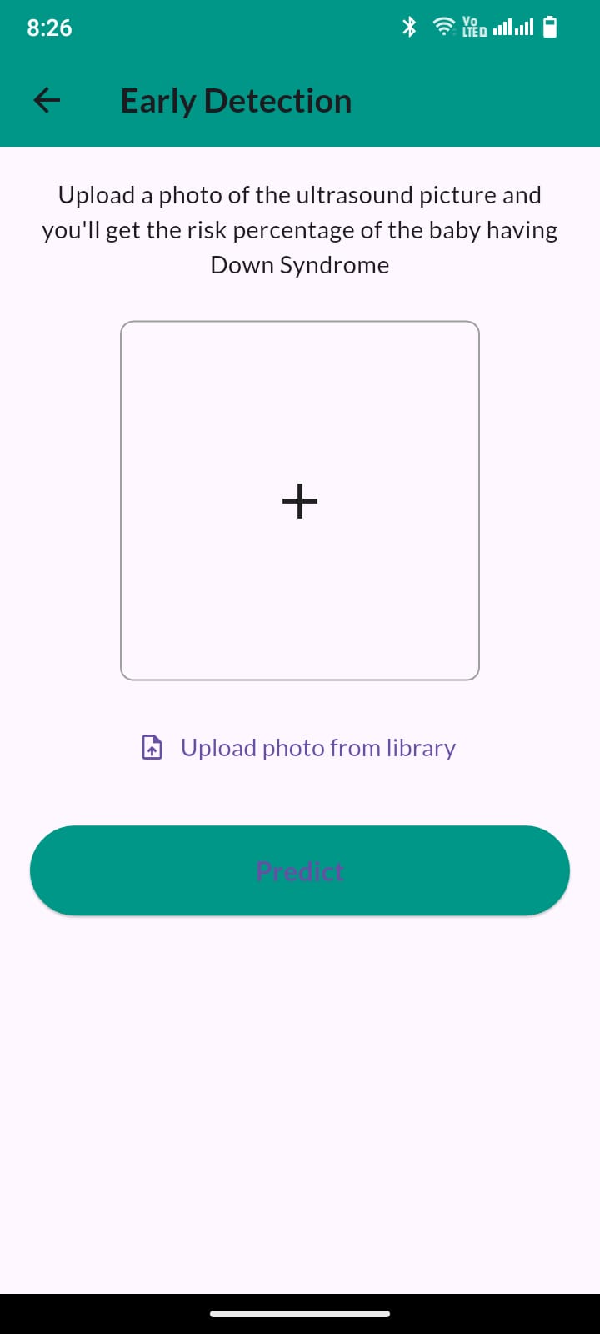

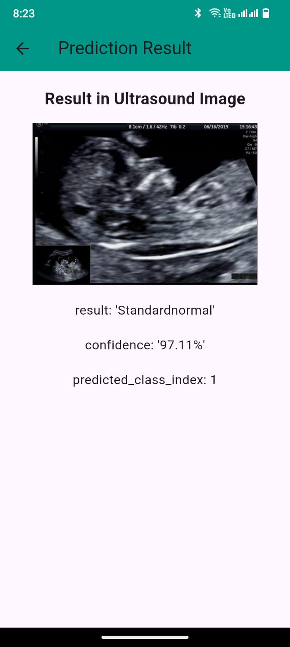

**Fig. 2.** Samples of UI screens**;** (a) Upload screen, (b) Detection Standard-Normal,

(c) Detection Non-Standard expected

### 3.2 Backend Phase

The backend phase forms the operational core of the proposed system, facilitating early detection of Down Syndrome and delivering tailored support resources to parents. This phase orchestrates the flow of data between the user interface, AI inference engine, and content support modules, ensuring both functional robustness and user security. At its core, the backend manages user interactions such as account registration, authentication, and secure session handling. It processes uploaded ultrasound images, prepares them for analysis, and interfaces with the prediction engine. Once the AI system generates inference results, these outputs are returned to the frontend for visualization and interpretation by healthcare professionals and users. A key component of the backend is its ability to dynamically integrate with external educational content platforms. Through this integration, the system retrieves multimedia resources related to Down Syndrome—such as therapeutic guides and educational videos—tailored to the specific needs of parents and caregivers. These resources are stored and indexed for quick retrieval, enabling timely access to relevant content. The backend also enables the structured management of various therapeutic and developmental tools. These include language and communication guides, exercises for motor and cognitive development, and directories linking users to medical professionals and support communities. Efficient data handling processes ensure these resources are categorized, retrievable, and regularly updated. Security and privacy are foundational to all backend processes. The system employs rigorous access control and encrypted communication channels to protect sensitive medical data. All interactions, from API calls to data transfers, are safeguarded by layers of authorization, validation, and monitoring to uphold compliance with privacy standards. The backend is architected to be modular and scalable, supporting future enhancements such as real-time communication with therapists, personalized notifications, and longitudinal tracking of developmental progress. In collaboration with the AI engine, the backend facilitates training and evaluation of predictive models. Data preprocessing, validation, and performance monitoring are conducted to ensure model reliability and generalization. This infrastructure supports iterative learning and optimization, allowing the system to continuously improve its diagnostic accuracy and effectiveness over time.

Figure 3 shows the backend process in the system.

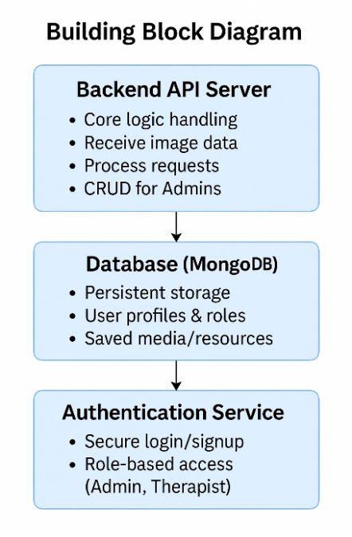

**Fig. 3.** Building block of the proposed Down Syndrome Detection app

**Model Architecture** For effective feature extraction and efficient deployment on mobile devices via a Flutter-based mobile application, transfer learning was utilized. The model down_detect_v1.keras was built upon a pre-trained convolutional neural network (CNN) backbone—chosen for its balance of accuracy and computational efficiency.

**The architecture included the following layers:**

A pre-trained CNN (EfficientNetB0) as the base for feature extraction, with ImageNet weights and the top classification layers removed , Global Average Pooling to reduce dimensionality while retaining spatial information , Fully connected Dense layers to map high-level features to class probabilities , A final Dense layer with a sigmoid or softmax activation (depending on binary or categorical classification) to output class predictions.To address the observed class imbalance during early evaluations, **class weighting** was applied. Furthermore, **focal loss** was tested to reduce overconfidence in misclassified predictions. These adjustments helped stabilize the learning curve and improved generalization.

# Experimental Results and Discussion

To ensure accuracy and reliability, the AI model undergoes extensive testing. Key performance indicators include: Precision, Recall, and F1-score to measure accuracy in classification tasks, Mean Average Precision (mAP) to assess the object detection model’s effectiveness , ROC Curve & AUC Score to determine the model’s ability to detect Down Syndrome risk.

Additionally, ongoing refinements are made through: Comparing AI predictions with expert medical assessments , Expanding the dataset with new ultrasound images from research collaborations , Regular updates to the AI model to align with the latest advancements in prenatal screening.

After training, the model was saved as down_detect_v1.keras and evaluated on the test dataset. While it demonstrated promising accuracy, analysis of misclassified images highlighted the need for further improvement. This led to an iterative refinement approach including: Applying data augmentation (e.g., rotation, zoom, flip) to increase data variability ,

Experimenting with Focal Loss to better handle class imbalance , Hyperparameter tuning (learning rate, batch size, etc.) , Exploring alternative pretrained models for higher accuracy and mobile efficiency , The results of each version were compared using confusion matrices, classification reports, and visual inspection of prediction outputs. The most reliable and efficient version was selected for integration into the system.

Upon evaluation, the model displayed the following performance:

For **precision**, the scores were 0.97 for Non-Standard cases, 0.88 for Standard cases, with a macro average of 0.93 and a weighted average of 0.93. In terms of **recall**, the model achieved 0.89 for Non-Standard and 0.97 for Standard, again with both macro and weighted averages equal to 0.93. Regarding the **F1 score**, the model recorded 0.93 for Non-Standard, 0.92 for Standard, with macro and weighted averages also at 0.93. The overall **test accuracy** was 93% (0.93), indicating a well-balanced performance across both classes. The confusion matrix illustrates the performance of the final trained model on the test dataset. Out of the 1,244 Non-Standard ultrasound images, the model correctly classified 1,108 as Non-Standard and misclassified 136 as Standard. Similarly, out of the 1,061 Standard images, 1,029 were correctly classified, while 32 were incorrectly predicted as Non-Standard. These results reflect a strong classification performance, particularly in minimizing false negatives, which is critical in medical screening applications. The model demonstrates high sensitivity and specificity, contributing to its overall accuracy of 93%.

Table 1 compares classification results of EfficientNetB0) model and (EfficientNetB3) Model.

|  |  |  |  |  |
| --- | --- | --- | --- | --- |
|  | Precision (%) | Recall (%) | F1 Score (%) | Test Accuracy (%) |
| **EfficientNetB0** | 93 | 93 | 93 | 93 |
| **EfficientNetB3** | 62 | 62 | 61 | 62 |

**Table 1.** Comparison of used (EfficientNetB0) model and (EfficientNetB3) Model

**Figure 4** Training progress of EfficientNetB0 vs. EfficientNetB3. The EfficientNetB0 model consistently outperforms the EfficientNetB3, achieving higher training and validation accuracy throughout all epochs.

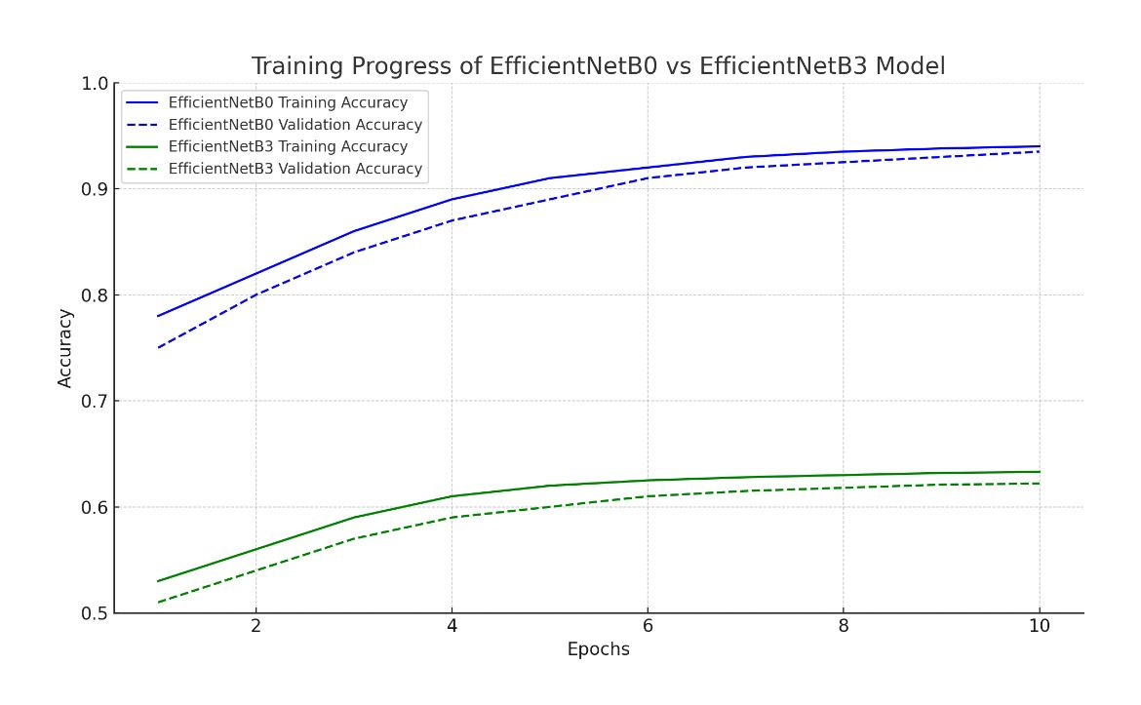

**Fig. 4.** Training progress of EfficienNetB0 vs EfficientNetB3

Figure 5 compares the confusion matrix obtained from the model. As can be observed from the confusion matrix a strong ability to detect both Standard and Non-standard cases, with only a few misclassifications. The use of a well-balanced dataset, augmentation, and focal loss significantly contributed to these results.

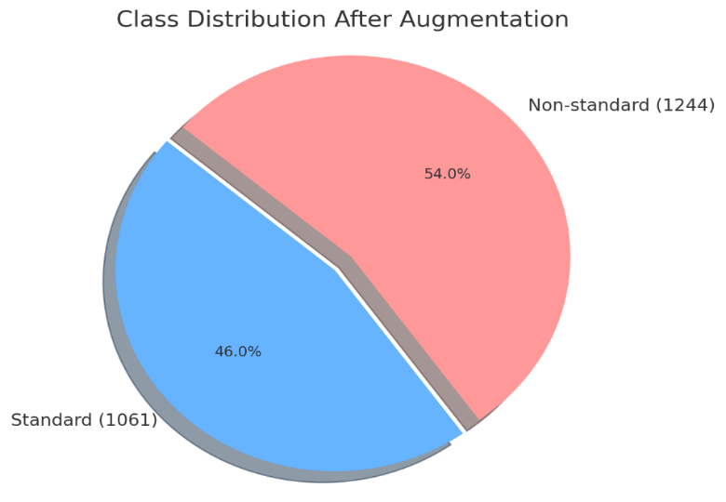

**Fig. 1.** Class distribution after applying augmentation

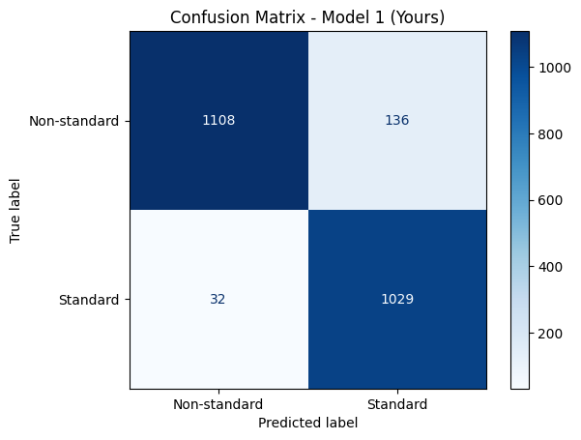

**Fig. 5.** Confusion Matrix of the model

The work demonstrates that with a well-curated ultrasound dataset and modern deep learning techniques, early detection of Down Syndrome is feasible and accurate. The model, once integrated into a user-friendly mobile application, has the potential to assist medical professionals and expectant parents in receiving rapid, non-invasive risk assessments. While it is not a replacement for medical diagnosis, DownDetect serves as a promising tool for early screening and awareness.

# Conclusion

The DownDetect system presents a significant advancement in the early detection and support of Down syndrome through the integration of advanced artificial intelligence and modern mobile technology. By leveraging a robust CNN model built on EfficientNetB0, the system achieves high diagnostic accuracy (93%) in analyzing fetal ultrasound images, offering a non-invasive, accessible screening tool for expectant parents. The system goes beyond diagnosis by providing a comprehensive ecosystem of educational content, community support, and connections to medical and therapeutic services. Its intuitive Flutter-based frontend and scalable Node.js backend ensure real-time responsiveness and secure data handling. This work demonstrates the potential of AI-driven tools to bridge the gap between clinical care and daily support, especially for families in underserved areas. While not a replacement for professional medical evaluation, DownDetect empowers families with timely insights, promoting early awareness and better preparedness for lifelong care and developmental planning.Future work will focus on expanding the dataset, refining the AI models, and integrating more personalized support features to further improve accuracy, usability, and impact.

# References

* 1. Razali, N. F., Isa, I. S., Sulaiman, S. N., Abdul Karim, N. K., Osman, M. K., & Che Soh, Z. H. (2023). Enhancement Technique Based on the Breast Density Level for Mammogram for Computer-Aided Diagnosis. Bioengineering, 10(2), 153.
  2. Darwish, A., Sayed, G., & Hassanien, A. (2018). Meta-heuristic optimization algorithms based feature selection for clinical breast cancer diagnosis. Journal of the Egyptian Mathematical Society, 26(2), 321-336.
  3. Hussain, M., Koundal, D., & Manhas, J. (2023). Deep learning-based diagnosis of disc degenerative diseases using MRI: A comprehensive review. Computers and Electrical Engineering, 105, 108524.
  4. Sayed, G. I., Solyman, M., & Hassanien, A. E. (2019). A novel chaotic optimal foraging algorithm for unconstrained and constrained problems and its application in white blood cell segmentation. Neural Computing and Applications, 31, 7633-7664.
  5. Saeedi, S., Rezayi, S., Keshavarz, H., & R Niakan Kalhori, S. (2023). MRI-based brain tumor detection using convolutional deep learning methods and chosen machine learning techniques. BMC Medical Informatics and Decision Making, 23(1), 1-17.
  6. Yamanakkanavar, N., Choi, J. Y., & Lee, B. (2020). MRI segmentation and classification of human brain using deep learning for diagnosis of Alzheimer’s disease: a survey. Sensors, 20(11), 3243.
  7. Wahlang, I., Maji, A. K., Saha, G., Chakrabarti, P., Jasinski, M., Leonowicz, Z., & Jasinska, E. (2022). Brain magnetic resonance imaging classification using deep learning architectures with gender and age. Sensors, 22(5), 1766.
  8. Wu, S. B., Li, Z. M., Gao, J., Zhou, H., Wang, C. S., & Jin, X. M. (2023). Classification of quantum correlation using deep learning. Optics Express, 31(3), 3479-3489. 10
  9. Kamruzzaman, A., Alhwaiti, Y., Leider, A., & Tappert, C. C. (2020). Quantum deep learning neural networks. In Advances in Information and Communication: Proceedings of the 2019 Future of Information and Communication Conference (FICC), Volume 2 (pp. 299 311). Springer International Publishing.
  10. Kamruzzaman, A., Alhwaiti, Y., Leider, A., & Tappert, C. C. (2020). Quantum deep learning neural networks. In Advances in Information and Communication: Proceedings of the 2019 Future of Information and Communication Conference (FICC), Volume 2 (pp. 299 311). Springer International Publishing.
  11. Kodipalli, A., Fernandes, S. L., Dasar, S. K., & Ismail, T. (2023). Computational Framework of Inverted Fuzzy C-Means and Quantum Convolutional Neural Network Towards Accurate Detection of Ovarian Tumors. International Journal of E-Health and Medical Communications (IJEHMC), 14(1), 1-16.
  12. Ovalle-Magallanes, E., Avina-Cervantes, J. G., Cruz-Aceves, I., & Ruiz-Pinales, J. (2022). Hybrid classical–quantum Convolutional Neural Network for stenosis detection in X-ray coronary angiography. Expert Systems with Applications, 189, 116112.
  13. Contributors: Chen Cui , Fajin Dong | Published: 21 September 2022 | <https://data.mendeley.com/datasets/n2rbrb9t4f/1> (Last opened: 9 May 2025)